Subnetting Practice 2
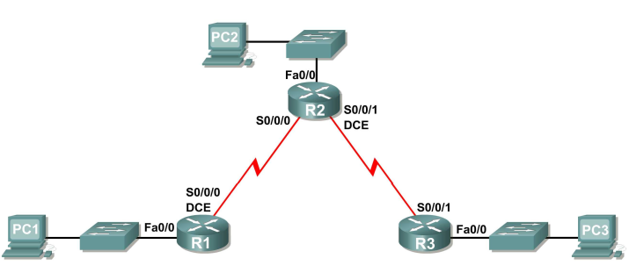
- You have been given the above topology diagram that you need to create. You have been supplied the network address of 192.168.20.0 /26 that you need to subnet to accommodate the above topology.
  - The subnet containing PC1 can have 4 hosts;
  - The subnets containing PC2 and PC3 can have up to 6 hosts each;
  - The WAN link subnets can have 2 hosts each.

Each network will use the same mask.
Complete the subnetting exercise and fill in the below table.

5 networks needed (as per diagram)
Need to borrow 3 bits = 8 networks (8-5 = 3 networks left over for future use)
New prefix = /29 (3 host bits remaining)
Another way to see the host bits is to look at in binary = New mask for 4th octet in binary is 11111000 (originally was 11000000, but we borrowed 3 bits).
3 host bits = 6 usable hosts (2³-2)
Network increment = 8 (number of host ip addresses before subtracting 2)
New dotted decimal mask = 255.255.255.248
Networks can be assigned in any order in below table.

Subnet | Network Address | First Useable Host | Last Useable Host | Broadcast Address
R1–R2 – WAN | 192.168.20.0 | 192.168.20.1 | 192.168.20.6 | 192.168.20.7
R2–R3 – WAN | 192.168.20.8 | 192.168.20.9 | 192.168.20.14 | 192.168.20.15
R1 – Fa0/0 – LAN | 192.168.20.16 | 192.168.20.17 | 192.168.20.22 | 192.168.20.23
R2 – Fa0/0 – LAN | 192.168.20.24 | 192.168.20.25 | 192.168.20.30 | 192.168.20.31
R3 – Fa0/0 – LAN | 192.168.20.32 | 192.168.20.33 | 192.168.20.38 | 192.168.20.39
3 remaining networks for future use are
192.168.20.40
192.168.20.48
192.168.20.56

